**GO-STANDARD NURSERY & PRI-SCHOOL**

**MID YEAR EXAMINATION 2023**

**BABY CLASS: (3 – 4 YEARS)**

**LEARNING AREA 3: HEALTH HABITS**

**My name is: ……………………………………………………………….**

**My School is: …………………………………….………………………..**

**I am in: ………………………………..…………………………….…………………..**

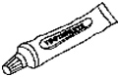I. **Match and draw things we use to clean our body.**

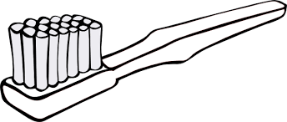 ____________

Colgate

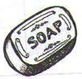 ___________

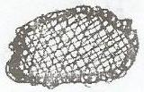

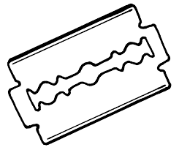 ___________



 ___________



___________

2. **Copy and draw garden tools**.

|  |  |  |
| --- | --- | --- |
| D:\Local Disk F\New folder\KIBUUKA FOLDER\images\DISAN PICS\pics\hoe doll.jpg | D:\Local Disk F\New folder\SECRETARY\NEW PICS\MY PHOTOS\PICTURES\LISA EVE\panga.png | D:\Local Disk F\New folder\ODONGO\JIREH\DISAN 2020\pic\pics\AXE FR.png |
|  |  |  |

3. **Make animal sounds**.

A cow says ……………..……

A cat says …………………..

A goat says …………………..

A hen says …………………..

4. **Match and draw**.

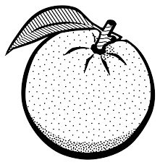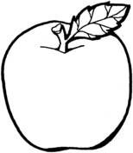

______________

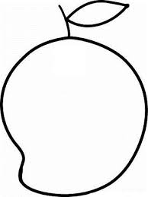

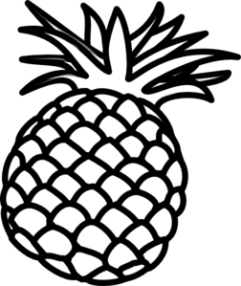

______________

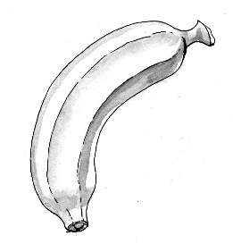



______________





_____________



_____________

5. **Shade me please**.

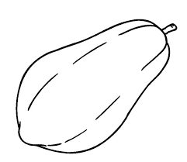



**END**